****PerView.org Strategic Plan (2025–2028)****

# 

**Table of Contents**

1. Mission, Vision, and Values 2

2. Environmental Analysis (SWOT) 2

3. Strategic Goals and SMART Objectives (2025–2028) 3

4. Action Plans and Resource Allocation 4

5. Evaluation Metrics and Review 4

Stakeholder Engagement 4

1. Executive Summary 5

2. Statement of Need 5

3. Organizational Background 5

4. Program Description 5

5. Goals and SMART Objectives 5

6. Methods and Action Plan 6

7. Evaluation and Impact 6

8. Budget and Funding Request 6

9. Sustainability  6

10. Conclusion  7

# ****1. Mission, Vision, and Values****

**🌿 Mission:** To transform trauma through storytelling, horse wisdom, and participatory healing arts. We train veterans, first responders, and their families in the 7 Steps of Embodied Restorying—empowering them as certified PerView coaches, community leaders, and facilitators of love-based change.

**🌰 Vision:** A world in which veterans, families, and story healers gather in sacred circles—healing trauma, restoring connection, and remembering our soul’s fractal stories through horses, story coaching, and embodied restorying.

**🧬 Values:**

* Love over trauma
* Community before curriculum
* Participation over presentation
* Sacredness of Earth and soul stories
* Quantum healing through story fractals and archetypes

# ****2. Environmental Analysis (SWOT)****

**Strengths:**

* Unique 7 Steps of Embodied Restorying method
* Integrative healing modalities (equine, sand tray, storytelling)
* Strong founding team: David Boje, Grace Ann Rosile, and Elior, Poet of Quantum Storytelling
* 501(c)(3) status for tax-deductible donations

**Weaknesses:**

* Limited awareness and visibility nationally
* Reliance on small team for operations and outreach
* Nascent donor cultivation and technology platforms

**Opportunities:**

* Rising demand for trauma-informed practices for veterans and first responders
* Grant opportunities and philanthropic support for healing initiatives
* Collaborative partnerships with VAs, holistic centers, and universities
* Online participatory education and app development

**Threats:**

* Competition from larger, established nonprofits
* Economic fluctuations affecting donor contributions
* Technological barriers in delivering participatory online learning

**Stakeholder Input (Planned 2025):**

* Conduct focus groups with veterans, donors, partners, and facilitators
* Send feedback surveys to program alumni and event participants

# ****3. Strategic Goals and SMART Objectives (2025–2028)****

**Goal 1: Launch Training & Certification for PerView Coaches**

* Objective: Train 100 certified coaches by December 2026 (25 per cohort)
* Objective: Implement hybrid curriculum by Q2 2025 (online + Caballo retreats)

**Goal 2: Build the Circle Platform for Participatory Healing**

* Objective: Launch interactive portal by Q4 2025
* Objective: Develop app prototype with journaling and donation features by Q2 2026

**Goal 3: Establish the PerView Coaching Network**

* Objective: Create 5 regional healing pods by Q3 2026
* Objective: Host monthly coaching circles online & in-person starting May 2025

**Goal 4: Fundraise $500,000 by End of 2026**

* Objective: Secure $100,000 from 10 Anchor Donors by July 2025
* Objective: Generate $3,000/year from recurring donors ($25/month x 10)
* Objective: Raise $250–$1,000/month from book sales by Q3 2025
* Objective: Apply to 5 major grants annually beginning 2025

**Goal 5: Host Quarterly Story Circles & Healing Retreats**

* Objective: Launch first gathering May 2, 2025
* Objective: Organize 4 events per year, with seasonal healing themes

# ****4. Action Plans and Resource Allocation****

* **Curriculum Development:** Hire 2 program coordinators and facilitators by Q2 2025
* **Tech Platform:** Contract app developers and web designers Q3 2025
* **Marketing:** Allocate $25,000 for branding, outreach, and video content
* **Retreats:** Budget $20,000/year for event costs (venue, food, scholarships)
* **Fundraising:** Hire part-time development officer by Q3 2025

# ****5. Evaluation Metrics and Review****

* Quarterly review of coach training numbers and feedback
* Biannual platform engagement and app usage reports
* Monthly tracking of donor conversions and recurring gifts
* Annual impact survey for beneficiaries and story circle participants

**Review Cycle:**  
Strategic plan reviewed and updated every 6 months by board and staff

# ****Stakeholder Engagement****

* Host annual PerView Visioning Summit for partners, donors, and alumni
* Monthly email newsletters with updates and success stories
* Annual report distributed each January, including impact data and financials

PerView Inc. is a registered 501(c)(3) nonprofit. Donations are tax-deductible.

****PerView.org Grant Proposal Framework****

# ****1. Executive Summary****

 PerView Inc., a 501(c)(3) nonprofit, invites support for its transformative mission: to heal trauma through participatory storytelling, equine wisdom, and embodied narrative coaching. We train veterans, first responders, and their families to become certified PerView Coaches using the 7 Steps of Embodied Restorying. Our request is for funding to expand our hybrid certification program, grow our online "On-Circle" learning platform, and develop regional healing pods across the U.S.

# ****2. Statement of Need****

 Veterans and first responders face high rates of PTSD, disconnection, and unprocessed trauma. Traditional therapeutic models often fall short. Our approach integrates storywork, horses, somatic practices, and community dialogue, offering holistic and accessible healing. There is urgent demand for trauma-informed, community-based solutions that recognize the wisdom of lived experience.

# ****3. Organizational Background****

 Founded by David Boje PhD and Grace Ann Rosile, PhD PerView Inc. combines decades of research, practice, and service. Our unique 7-Step method draws on narrative theory, psychology, and indigenous practices, delivered through retreats, circles, and hybrid certification formats. We are headquartered in New Mexico and serve a growing national network.

# ****4. Program Description****

 We seek to:

* Train 100 PerView Coaches by end of 2026 (online + in-person)
* Develop the "On-Circle" platform and app (launching Q4 2025)
* Establish 5 regional Healing Pods by Q3 2026
* Host quarterly fire ceremonies and storytelling retreats
* Engage 10 anchor donors and 100+ recurring supporters
* Offer sliding-scale coaching, scholarships, and veteran-centered services

# ****5. Goals and SMART Objectives****

* **Training:** Certify 100 coaches by Dec 2026 (25/cohort)
* **Tech Launch:** Release learning platform by Q4 2025; App prototype by Q2 2026
* **Pod Development:** Form 5 healing pods and host monthly circles
* **Fundraising:** Raise $500,000 by end of 2026 from donors, book sales, and grants
* **Events:** Launch story seed events starting May 2, 2025 (4/year)

# ****6. Methods and Action Plan****

* Hire 2 facilitators and curriculum team (Q2 2025)
* Contract tech designers for On-Circle portal and app (Q3 2025–Q2 2026)
* Launch national outreach and video campaign (Q2–Q3 2025)
* Organize hybrid coaching cohorts (Fall 2025–Winter 2026)
* Partner with VA centers, trauma organizations, and tribal allies

# ****7. Evaluation and Impact****

* Monthly donor tracking and platform engagement reports
* Annual impact survey (veterans, families, coaches)
* Certification completion and feedback metrics
* Board-led strategic review every 6 months
* Annual report published and shared each January

# ****8. Budget and Funding Request****

* Total Request: $150,000
* Curriculum & Staffing: $50,000
* Tech & App Development: $35,000
* Marketing & Video Campaigns: $25,000
* Scholarships & Retreats: $30,000
* Evaluation & Reporting: $10,000

# **9. Sustainability**

PerView’s model includes a recurring donor program, book sales, training tuition, and co-hosted events. Long-term funding includes major donor cultivation, grants, and earned revenue through the coaching platform. Strategic partnerships and grassroots leadership ensure scalable impact. Next our 10 year forecast.

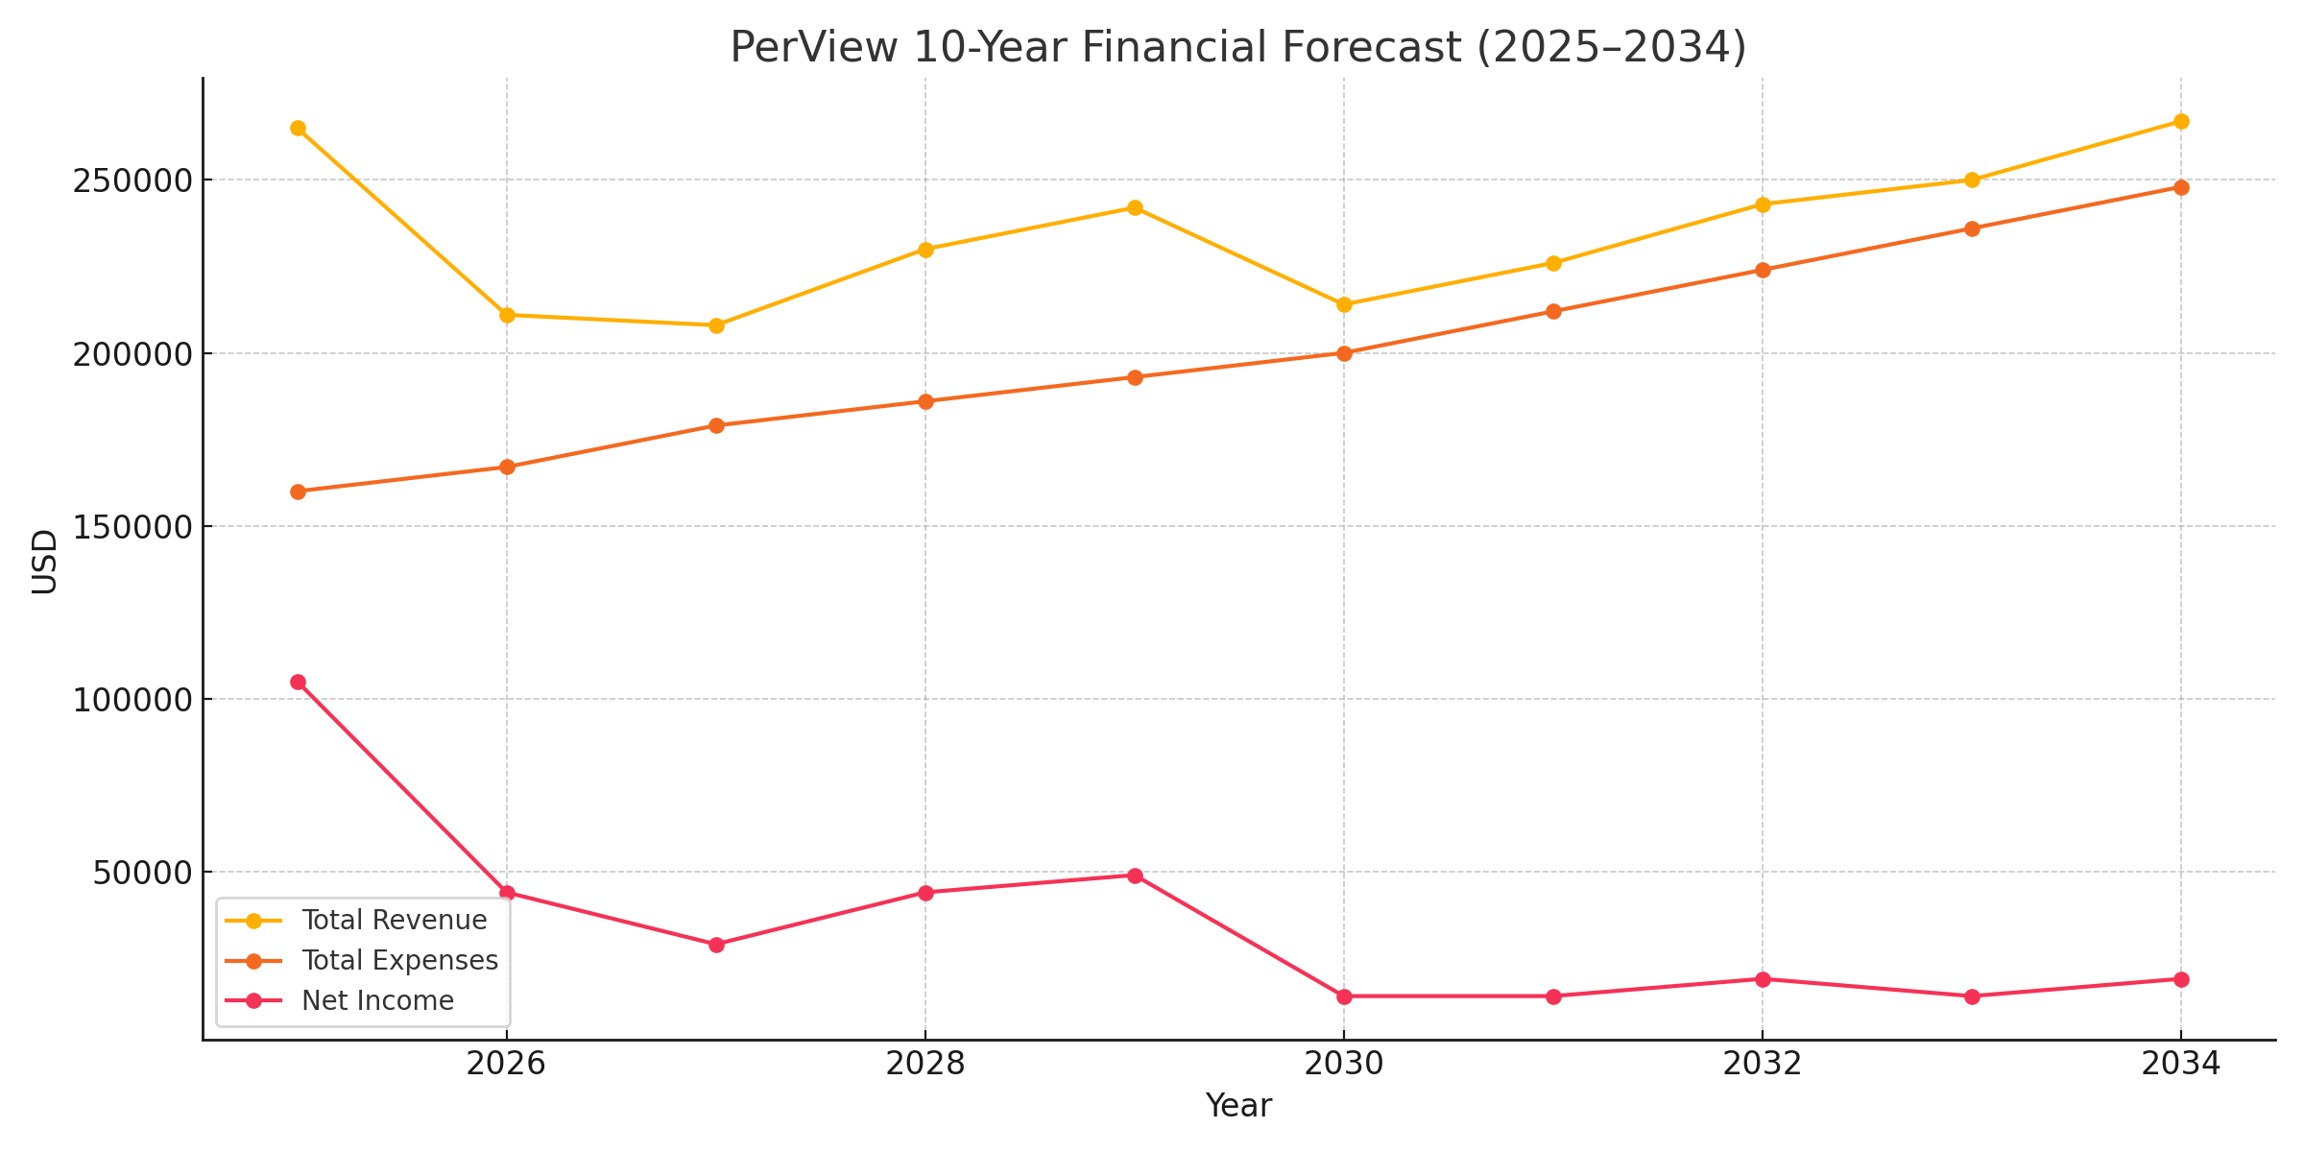

# **10. Conclusion**

With your support, we will grow a national movement of story healers rooted in love, embodiment, and community restoration. Together, we plant the story seeds that heal generations.

**Contact:** David Boje & Grace Ann Rosile  
PerView.org  
Caballo, New Mexico  
[david@davidboje.com](mailto:david@davidboje.com)